**CEA 2015-2016**

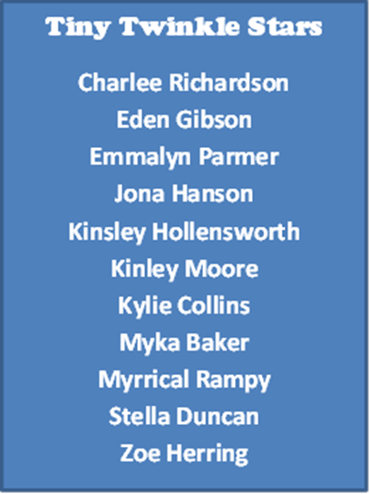

**Mini Meteors**

**Addison Chandler**

**Anslee Jester**

**Bella Baker**

**Chloe Collins**

**Hannah Kelly**

**Jasmine Kahler**

**Lily Orneales**

**Maggie Keyes**

**Marleigh Duncan**

**Wynter Dillard**

**Seniors Asteroids**

**Alison Westbrook**

**Alyssa Martin**

**Angie Cox**

**Caitlin Gummeson**

**Davis Sutton**

**Hallee Gentry**

**Hannah King**

**Hollan Palmer**

**Jazzlyn Gamble**

**Joy Bean**

**Karli Frazier**

**Kelsey Allgor**

**Kendall Wells**

**Laura Norman**

**Raven Betts**

**Junior Comets**

Ainsley Richardson

Alison Westbrook

Avery Rice

Breeann Parks

Davis Sutton

Grace Otwell

Hallee Gentry

Hollan Palmer

Jaden Runion

Kate Baker

Kendall Wells

Kynlee Garrett

Macie McClure

Madison Mills

Mary Claire Lynch

Toni Freeman

Hadley Butcher

Halie Kyles

Lola Vanderburg